——————————————————————————————————————————

Contents

1. What do we have

2. What can we predict using this

3. What problems you may be interested in solving

4. How they may be solved using the data we have

5. What future additional data we may need to solve new problems

——————————————————————————————————————————

1) What data do we have

Currently we have data that measures the frequency of the students’ general usage of the website. As suggested in the weekly meetings, measurements such as the total frequency of events such as pageviews, openNutshell, read, etc were measured in order to understand which features were used the most throughout the terms.

2) What can we predict using this

We can predict how the students interacted with the website such as how many times students visited the pages over term. We can also predict which events were useful during assignment periods for students. For example, the graph that represented the frequency of nutshell usage throughout the term showed how nutshells for both 2510 and 2520 term were used nearly at the end of the semester, close to when the final papers were due, which infers that the nutshells were especially useful for students when they were writing their papers. Furthermore, if we look at the frequency of pageview events, we can see a “M” shaped graph throughout the term. This implies that for some duration during the term, the students have been visiting the page a lot for a reason, and we can check that it was because of the assignment due dates as the dates match when the graph showed the peaks.

3) What problems would we be interested in solving

- Does the read event get triggered if the page is unscrollable?
- Does viewing the page necessarily lead the user to leave the page?
- Does opening the nutshell necessarily lead the nutshell to be inactive?
- When the students visit the page, do they just visit, or explore the website more by clicking into related internal links?

4) How the questions may be solved using the data we have right now

- This can be solved by using the viewport height and scrollY variables in our actual code. As mentioned in the meeting, the website first measures the total height of the website in pixels. Then, using viewport height, the website measures the amount of pixels that has been shown in the current screen. As soon as the viewport height becomes more than 50% of the total height, the read event gets triggered. However, for unscrollable pages, the viewport height is already more than 50% of the page, where the read event gets triggered despite the students have not even started scrolling nor reading. Hence, the read event does get triggered, leading us to an inaccurate way of measuring the event.

- When the data for pageview and pageleave gets visualized, we can realize how the pattern of the graph is similar. So, it is reasonable to say that most pageviews lead to pageleave, but it is crucial to specifically measure the ratio of pageview to pageleave to illustrate the precise percentage of the students actually leaving the page instead of forgetting it. Specific correlation shall be done in future analysis. In addition, it would also be possible to have pageview-pageleave pairs to understand which pages are viewed and left without the students forgetting it. This may also lead to analysis of what “focus” really means. Would we be able to say that “focus” is the amount of pageview-pageleave pairs? This also shall be determined during future analysis.

- Similar to the pageview and pageleave, openNutshell and inactiveNutshell had similar patterns. Of course, every openNutshell has not been converted to inactiveNutshell, but inactiveNutshell sure did happen only when openNutshell got triggered as the shape of the two graphs are the same.

- This question can be answered using internalLinkClick, which measures how many times students clicked links within the website while looking at pages, and which link within the website they went to while viewing a different page. According to the visualization, this also has similar patter with pageview and pageleave :
- 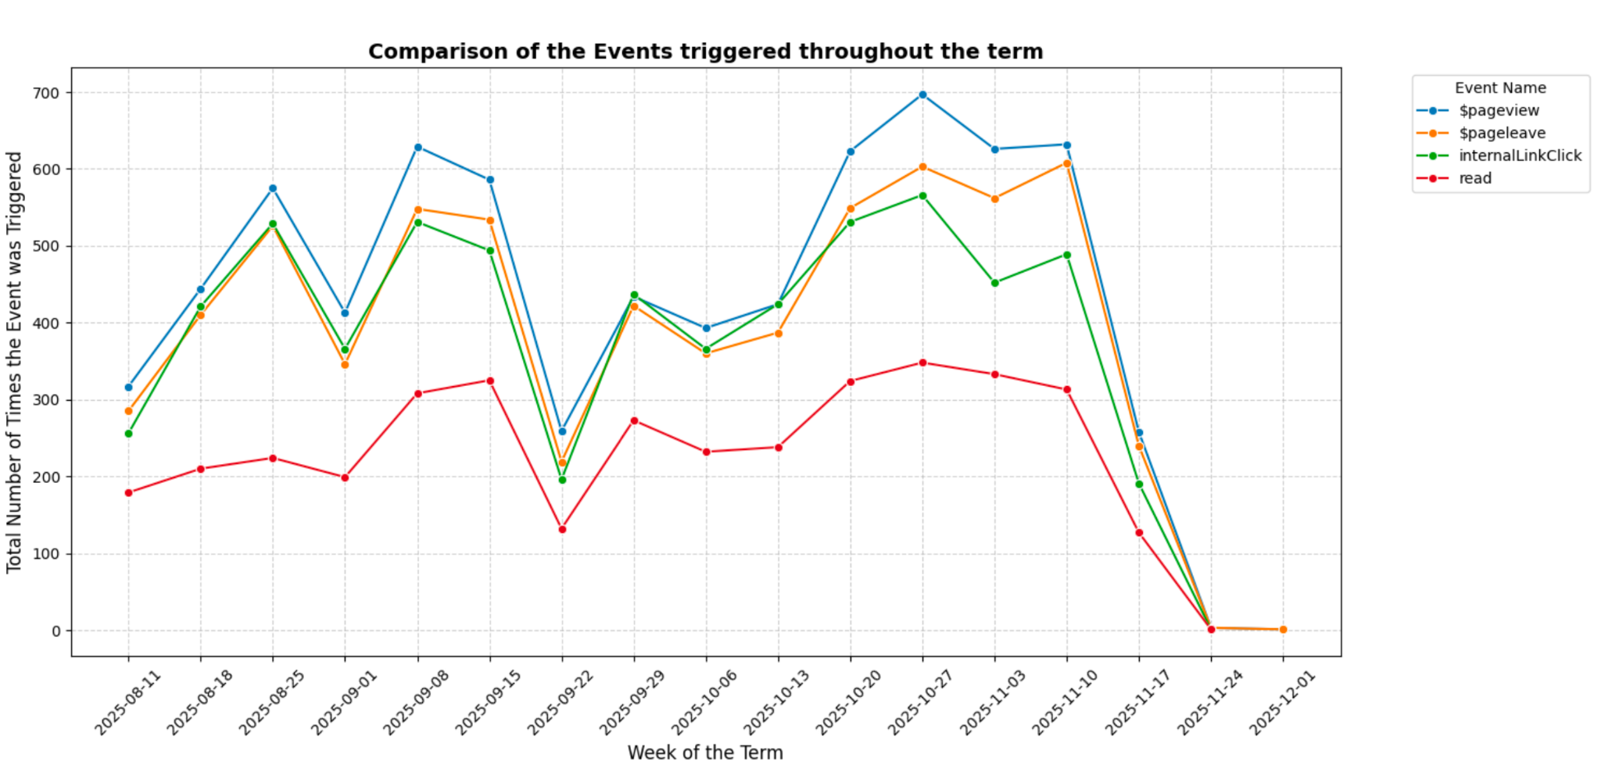

Hence, it is reasonable to say that upon pageview, internalLinkClick was triggered while the users were in that particular page, which implies that they have been exploring not only one content, but a wide variety of contents that the website has to offer.

5) What future additional data we may need to solve new problems

First, it would be helpful to know which new problems the Professor would be interested in solving. In order to identify these new problems, I first start with broad questions such as :

- How can we really define whether a student “focuses”? Which data would be helpful in determining that definition
- Which particular behavior would affect a student's comprehension of a particular term?

For now, these are two broad questions I can think of, and I have been thinking, for future analysis to solve these types of questions, it would be helpful to have the “grade” data of the students. This way, we can determine what were the most common trajectories “successful” students took. This would help out students having trouble with their grades and give them a hint where to focus on. Not only grades, but interaction between the website and the student is also important. If we want to know whether the student actually “understood” or “focused and actually read through the content of the page”. Hence, I would suggest features such as the mini quiz at the bottom of the page to examine the students’ comprehension.

